Chapter 14, Problem 48.

Find the transfer function V_{o}/V_{s} of the circuit in Fig. 14.86. Show that the circuit is a lowpass filter.

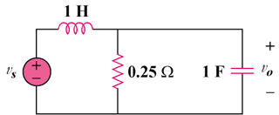

Figure 14.86
For Prob. 14.48.

